

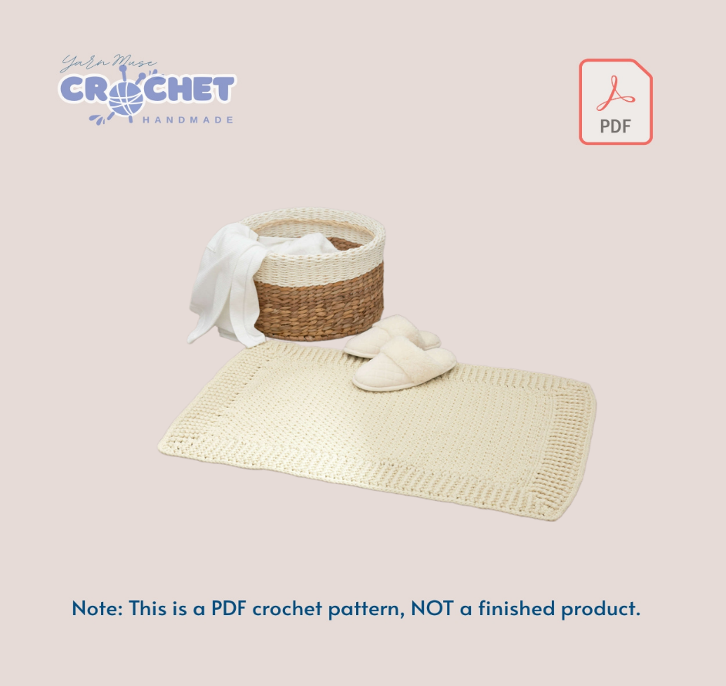

Crochet Home Decor Handmade Lifestyle PDF

© 2025 Yarn Muse Crochet. All rights reserved.
This pattern is for personal use only. Please do not sell, share, or repost this pattern (in whole or in part) anywhere online or offline. You’re welcome to sell finished items made from this pattern, but please credit Yarn Muse Crochet as the designer.

Pattern Details

Single Vanity Mat measures 22" (56 cm) x 32" (81.5 cm).
Double Vanity Mat measures 29" (73.5 cm) x 49" (124.5 cm).
Special Stitches: Back Loop Single Crochet (Bisc): Insert hook in back loop only of next st, yarn over, draw yarn through, yarn over, draw yarn through 2 loops on hook.
Front Loop Single Crochet (Fisc): Insert hook in front loop only of next st, yarn over, draw yarn through, yarn over, draw yarn through 2 loops on hook.
Back Post Double Crochet (BPdc): Yarn over, insert hook from back to front to back again around the post of next st, yarn, draw yarn through, [yarn over, draw through 2 loops on hook] twice. Front Post Double Crochet (FPdc): Yarn over, insert hook from front to back to front again around the post of next st, yarn, draw yarn through, [yarn over, draw through 2 loops on hook] twice.
MAT Single Vanity only Ch 54.
Row 1 (wrong side): Sc in 2nd ch from the hook, sc in each ch across, turn-53 sc.
Row 2: Ch 1, Blsc in first st, [Flsc in next st, Blsc in next st] across, turn-27 Blsc; 26 Fisc.
Row 3: Ch 1, Flsc in first st, [Blsc in next st, Fisc in next st] across, turn-27 Flsc; 26 Blsc.
Row 4-75: Repeat Rows 2-3 (36 times). Do not fasten off.
Double Vanity only Ch 78.
Row 1 (Wrong side): Sc in 2nd ch from the hook, sc in each ch across, turn-77 sc.
Row 2: Ch 1, Blsc in first st, [Flsc in next st, Bisc in next st] across, turn-39 Blsc; 38 Flsc.
Row 3: Ch 1, Fisc in first st, [Blsc in next st, Fisc in next st] across, turn-39 Flsc; 38 Blsc.
Row 4-125: Repeat Rows 2-3 (61 times).
Do not fasten off.
BOTH SIZES
Edging
Round 1 (right side): Ch 1, 3 sc in same
st (corner), sc in each st across to last st, 3 sc in last st (corner), working across side edge, sc in each row-end st across to beginning ch, 3 sc in first unused loop of beginning ch (corner), sc in each unused loop of foundation ch across to last ch, 3 sc in last ch (corner), working across side edge, sc in each row-end st across to beginning sc; join with a slip st in first sc.
Round 2: Ch 3 (counts as post dc here and throughout), *3 dc in center corner st, *[FPdc around the post of next st, BPdc around the post of next st] across to next corner st; repeat from around omitting last BPdc; join with a slip st in top of beginning ch-3.
Round 3: Ch 3, BPdc around the post of
next st, *3 dc in corner st, BPdc around the post of next st, [FPdc around the post of next st, BPdc around the post of next st] across to next corner st; repeat from around; join with a slip st in top of beginning ch-3.
Round 4: Ch 3, BPdc around the post of
next BPdc, FPdc around the post of next st, *3 dc in next corner st, FPdc around the post of next st, [BPdc around the post of next st, FPdc around the post of next st] across to next corner st; repeat from around, ending with BPdc in last st; join with a slip st in top of beginning ch-3.
Round 5: Ch 3, BPdc around the post of next BPdc, FPdc around the post of next FPdc, BPdc around next st, 3 dc in next corner st, BPdc around the post of next st, [FPdc around the post of next st, BPdc around the post of next st] across to next corner st; repeat from around; join with a slip st in top of beginning ch-3.
Round 6: Ch 3, [BPdc around the post of next st, FPdc around the post of next st] twice, BPdc around the post of next st, *3 dc in next corner st, FPdc around the post of next st, [BPdc around the post of next st, FPdc around the post of next st] across to corner st; repeat from * around ending with BPdc in last st; join with a slip st in top of beginning ch-3.
Round 7: Ch 3, [BPdc around the post
of next st, FPdc around the post of next st] twice, BPdc around the post of next st, *3 dc in next corner st, BPdc around the post of next st, [FPdc around the post of next st, BPdc around the post of next st] across to corner st; repeat from around; join with a slip st in top of begining ch-3.
Round 8: Ch 3, [BPdc around the post of next st, FPdc around the post of next st] 3 times, 3 dc in next corner st, FPdc around the post of next st, [BPdc around the post of next st, FPdc around the post of next st] across to corner st; repeat from around ending with BPdc in last st; join with a slip st in top of beginng ch-3.
Round 9: Ch 1, sc in same st, "sc in each
st across to next corner st, 3 sc in corner st; repeat from 3 times, sc in remaining st to beginning; join with a slip st in first sc. Fasten off.
ABBREVIATIONS
ch = chain; dc = double crochet; mm = millimeters; sc = single crochet; sl = slip; sp(s) = space(s); st(s) = stitch(es); yo = yarn over needle; [] = work directions in brackets the number of times specified; * or** = repeat whatever follows the or as indicated. ..
Contact Info:
If you have any questions or concerns about this pattern, please do not hesitate to contact me. I will get back to you within 24 hours.

☒ www.yarnmusecrochet.com   info@yarnmusecrochet.com  
 Facebook Messenger: https://www.facebook.com/yarnmusecrochet

For thousands of free patterns, visit our website:

☒ www.yarnmusecrochet.com   info@yarnmusecrochet.com  
 Facebook Messenger: https://www.facebook.com/yarnmusecrochet

